INVITATION FOR BID
Prime Minister`s Initiate on Clean & Green Energy

Design, Build and Installation of 300 KWp On-Grid Turnkey Photovoltaic Solar System
For promotion & Development of indigenous renewable energy resources in the country, for improving energy mix and to arrest drain of precious foreign exchange due to import of fossil fuels, the federal government (GOP) under the leadership of the Prime Minister of Pakistan has launched multiple Solar Power initiative. Solarization of Public Sector buildings through transparent competitive bidding process is one of the components of these initiatives.

Federal Board of Intermediate & Secondary Education Invites Bids for design, supply, Installation, Testing & Commissioning of Net Metering Based Solar PV System (300 KWP) at its office in H-8/4, Islamabad from the contractors/Firms registered with AEDB.

Single Stage Two Envelope Bidding Process will be adopted. Bidding documents containing detail terms & Conditions are available at FBISE website i.e. www.fbise.edu.pk for information of potential bidders. The price of bidding documents is Rs. 10,000/-which can be purchased from FBISE on or before 10-03-2023 through Bank Challan/Pay Order in Favor of Secretary FBISE. The bids of only those bidders will be considered who has purchased RFP. All bids accompanied by a bid Security amounting to Rs. 9,000/-per KW and all other documents as specified in the respective RFP must reach the office of Deputy Secretary (Procurement & Store) FBISE on or before March 16, 2023 at 14:00 hrs. The technical bids will be opened on the same date at 14:30 hrs in the presence of bidders representatives who choose to attend at the same address. This is advertisement is also available on www.fbise.edu.pk and www.ppra.org.pk.
(ARSHAD MEHMOOD)
DEPUTY SECRETARY
Procurement & Stores (FBISE)
H-8/4, Islamabad
Ph: 051-9269515

REFERENCE:BISE/ SOLAR / 300KWp
TOTAL PAGES INCLUDING COVER: 30

Bidding Document

FOR

PROCUREMENT OF300KWpROOFTOP ON-GRID SOLAR PV SYSTEM WITH NET METERING FOR FBUSE ISLAMABAD ON TURNKEY BASIS

Sr: # | Description | Part | Pages
1 | INTRODUCTION | PART-A | 2 - 8
2 | INFORMATION AND INSTRUCTION FOR BIDDER | PART-B | 9 - 15
3 | TECHNICAL SPECIFICATION/REQUIREMENT | PART-C | 16 - 20
4 | BID EVAULATION CRITERIA | PART-D | 21 - 22
5 | LIST OF FORMS TO BE SUBMITTED | PART-E | 23 - 30

RFP purchased by : Company Name:

Name and address

Issued by (Name and Signature)

BIDDING DOCUMENT
FOR
PROCUREMENT OF 300KWp ROOFTOP ON-GRID SOLAR PV SYSTEM WITH NET METERING AT FBISE ON TURNKEY BASIS

PART A - INTRODUCTION

FEBERAL BOARD OF INTERMEDIATE AND SECONDARY EDUCATION ISLAMABAD (FBISE) desires to purchase 300KWpRooftop Solar PV on-grid system with net metering on turnkey basis as per following distribution of PV Modules,

ROOFS | UNSHADED AREA FOR SOLAR PV MODULES (SQF) | SIZE OF MODULES ( KWp) CAN BE ACCOMDUATED
ROOF-1 | 6048 | 65
ROOF-2 | 2500 | 27
ROOF-3 | 5600 | 60
ROOF-4 | 3160 | 34
MASJID ROOF | 4300 | 46
ON WINDOW CELL | 4425 | 48
PARKING | 3900 | 42

SPACE AVAILEBLE IS FOR 322 KWp MODULES BUT YOU HAVE TO SUBMIT PROPOSAL FOR 300KWp SYSTEM.

NOTE: You will submit bid in US Dollar and at the time of the contract it will be converted into Pak Rupees as per Bank Exchange rate at the time of signing the contract.

Roof Area-1 in SQF ( 108ft x 56 ft.) =6048 SQF
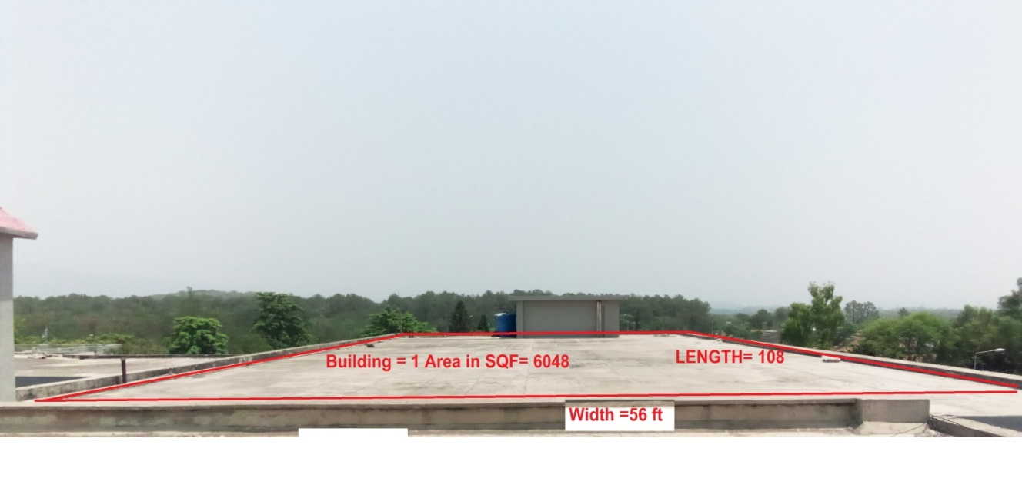

Roof Area-2 in SQF =Lx w (50 x 50) =2500 SQF
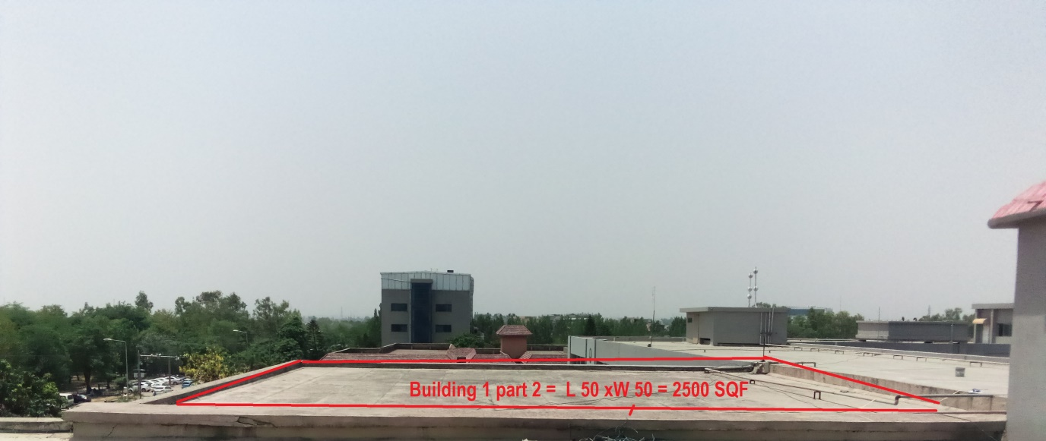

Roof Area - 3 in SQF =Lx w (140 X 40 ) = 5600 SQF
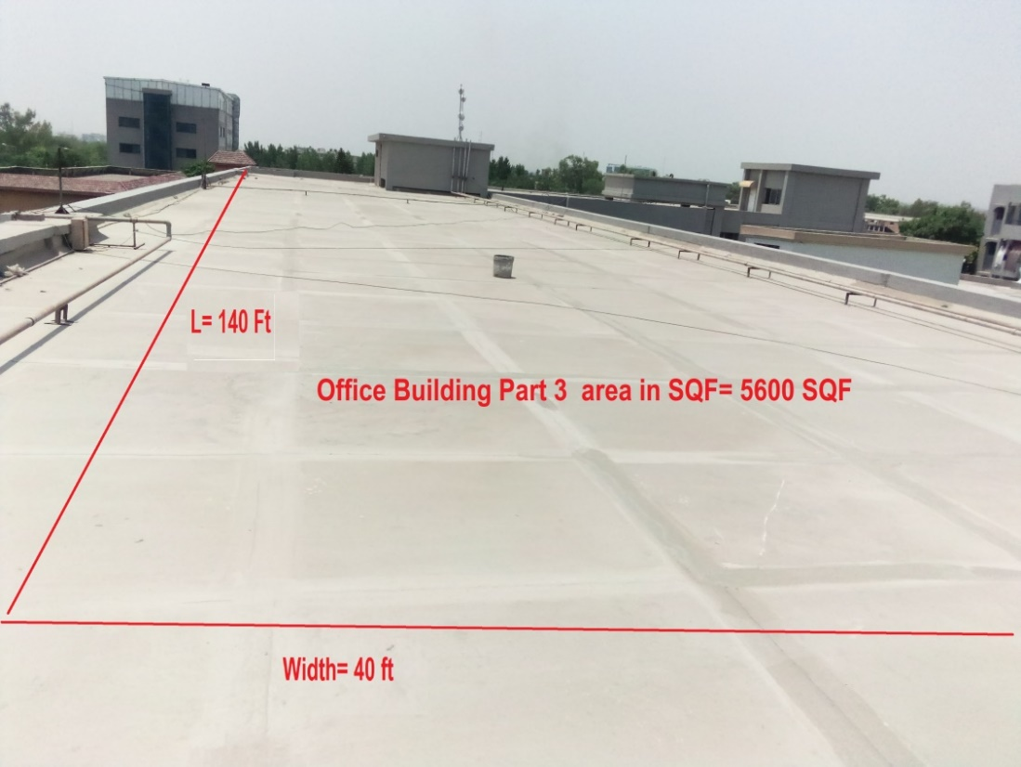

Roof area -4 in SQF =Lx w (79 X 40 ) = 3160 SQF

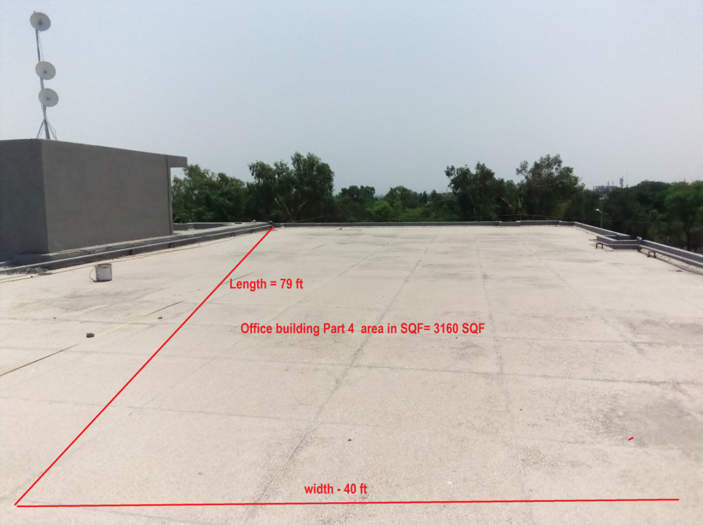

Roof area– 5 - Masjid Roof Area in SQF= 4300 SQF

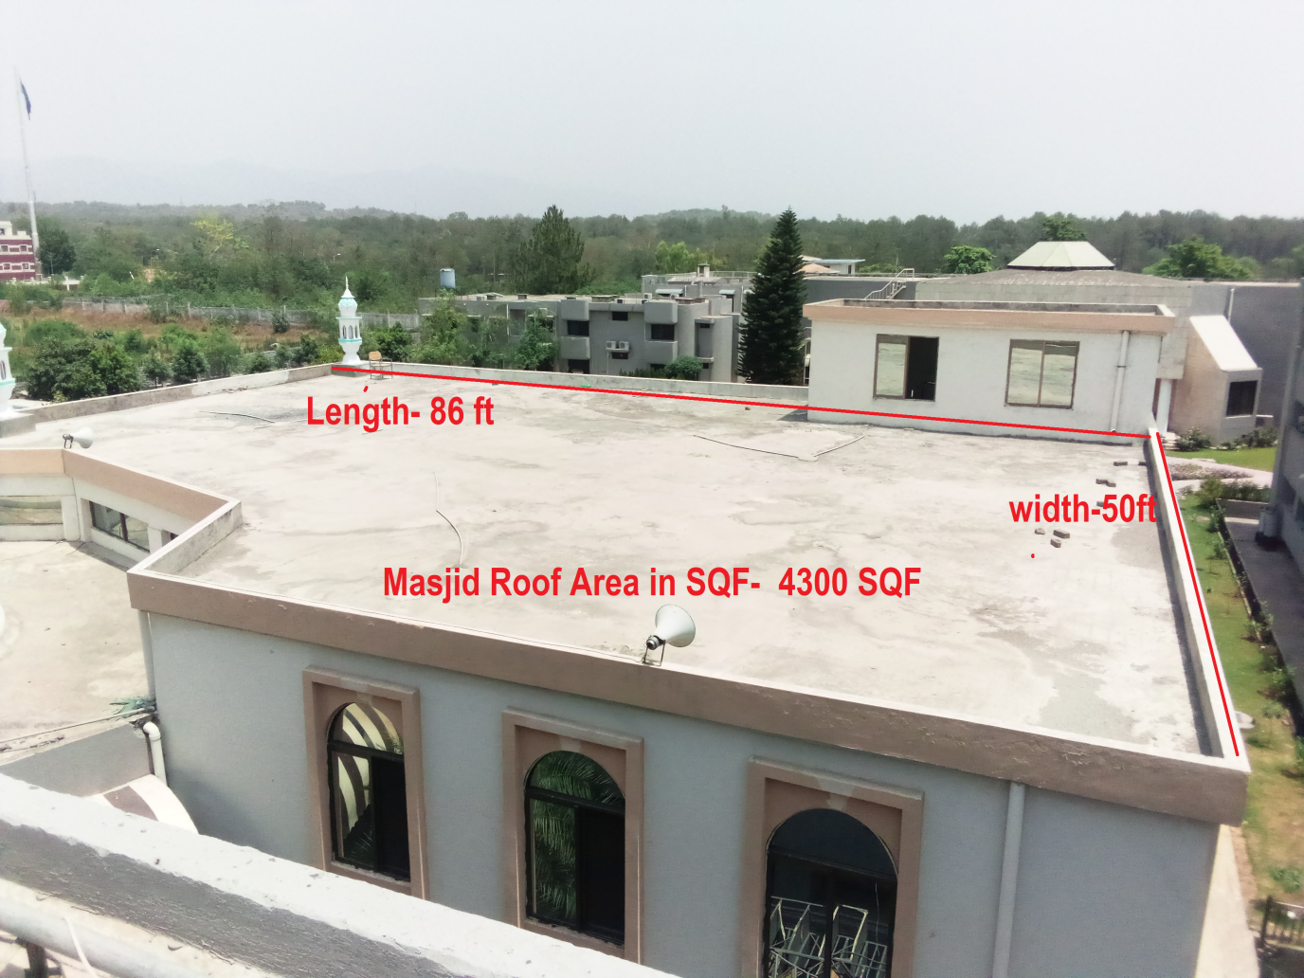

Car ParkingShed area– 6 in SQF=3900 SQF (Optional)

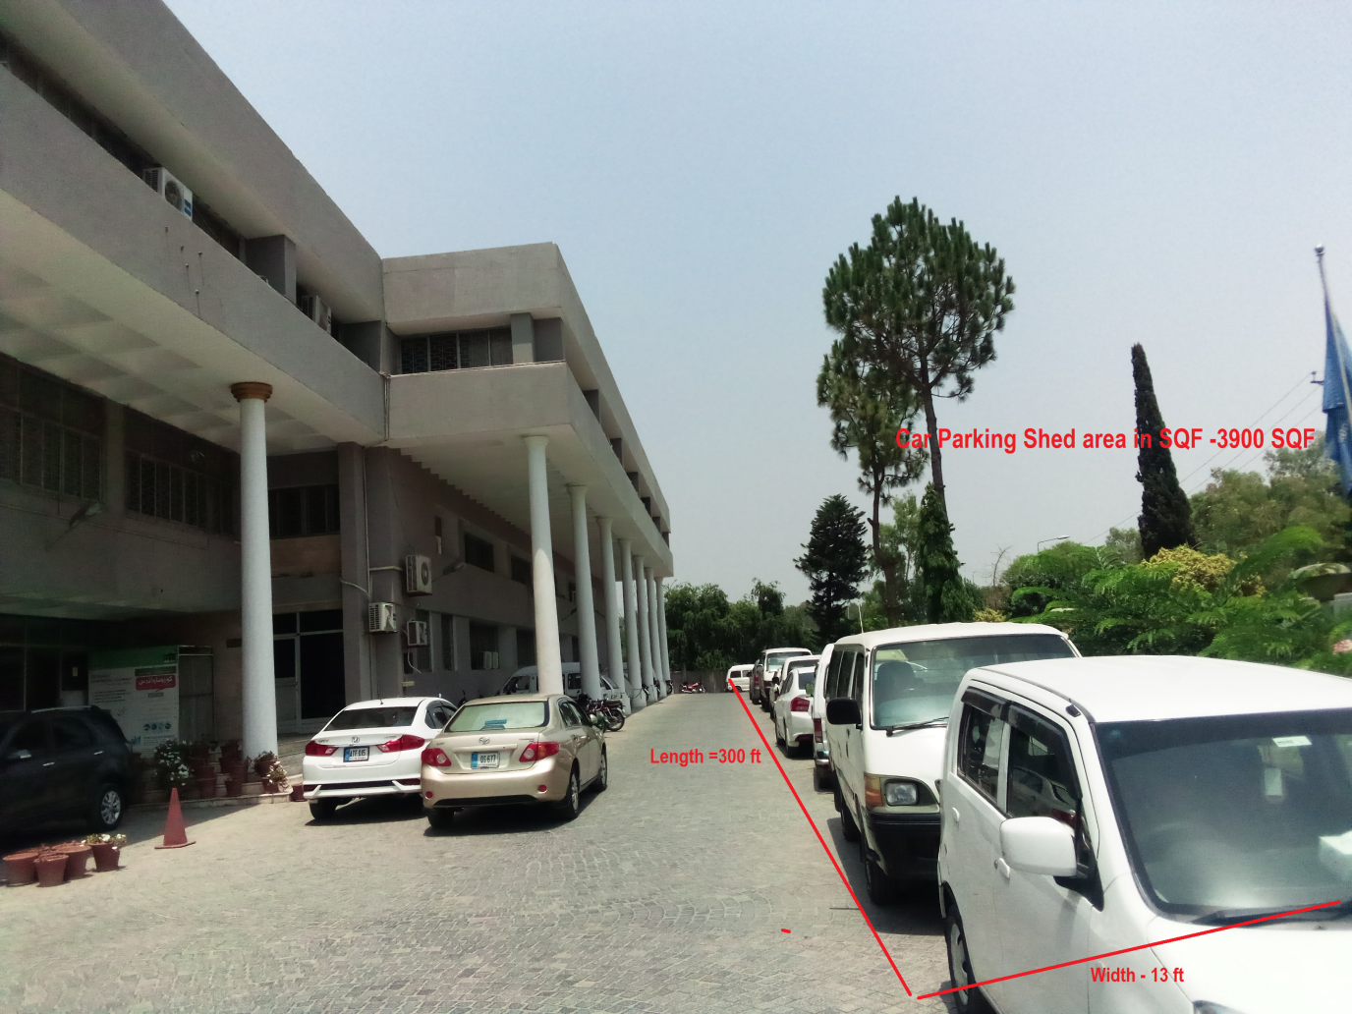

One window Cell Roof Area in SQF-4425 SQF

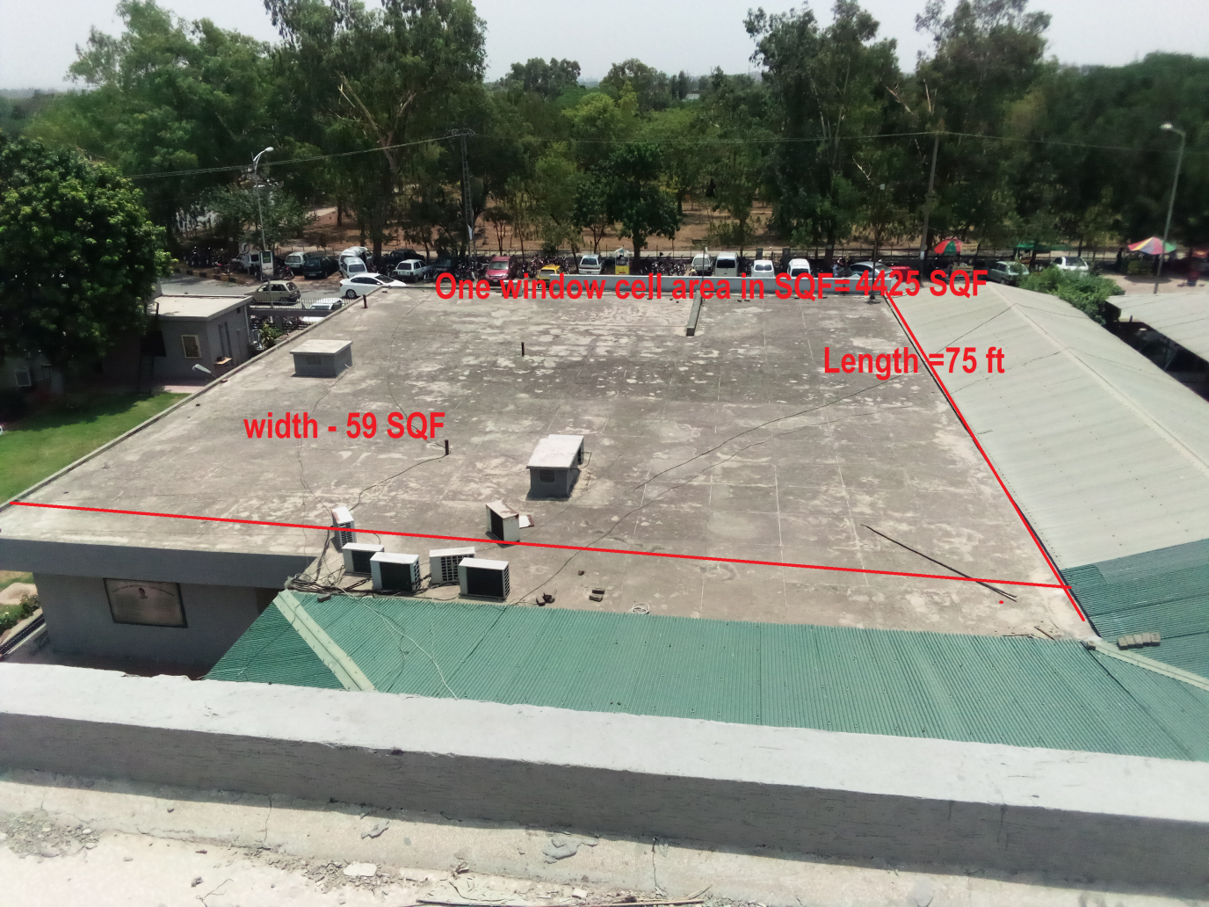

Sanction load of FBISE is 403 KW and one main Transformer of 630 KVA is energizing the whole FBISE Building through a common LV Panel which is 30ft away from Roof areas.
During load shedding Diesel Gen-Set is available which will be synchronized with PV System. Please provide complete PV Diesel Synchronization system enabling automatic start of Gen-Set and synchronized operation of PV system with Gen-Set supplying energy to load in safe manner. ATS is already available.

Solar PV Inverter output will be injected at main LT panel available but Bidder has to provide separate LV Safety Panel dedicated for Solar before injection into the FBISE LT side.
There will be a need for one Net Meter as there is one existing three phase Energy Meter to be replaced with one Net meter.

The bidders must supply LV Safety Panel complete with all protections and switching manufactured by a Quality Switchgear Company as per specifications given in technical specifications PART-C.

Height of building is approx. 25 meter and injection of AC output will be at main LT Panels available at site and bidders have to visit and decide suitable location for Inverter and LV Panel.

The purpose of RFP is to invite Bids from AEDB & PEC Licensed Companies having minimum three years of experience in Solar PV and active NTN/Sales Tax registration with FBR for procurement of aggregate “300KWpRooftop On-Grid Solar PV System at BISE Islamabad.” on turnkey basis as per technical requirement given in Part-C of this RFP.

PART-B. INFORMATION AND INSTRUCTIONS TO BIDDERS

1. Bids must be submitted in one envelope containing two envelopes inside in it.
2. 1stsealed envelope having technical offer be marked as “Technical Bid”.
3. 2ndsealed envelope having financial offer to be marked as “Financial Bid”.
4. Both envelopes to be placed in a one sealed envelope bearing Companies’ postal / email addresses and phone numbers etc. and marked as “Bid for 300KWpRooftop On-Grid Solar PV System on turnkey basis”. Bid should be addressed to

The Secretary, Federal Board of Intermediate and Secondary Education
H-8/4, Islamabad.
5. The project will be implemented on Turnkey basis at rooftops of FBISE on Turnkey basis. Turnkey means design, engineering, supply, installation, commissioning, and trial run with all Civil. Mechanical and Electrical works, warranties, training of client Persons and, after sales services including all permissions and Licenses.

6. 300KWp PV System is to be installed at rooftop of FBISE. By 300KWp solar PV systems means the 300KWp Solar PV modules at STC with total minimum 300 KWp Inverter size complete with mounting structures, DC/AC cables, AC Power Distribution Cabinet (LV Cabinet) with all civil, electrical, and mechanical work on turnkey basis with five years free service (Labor and material). Service means the availability/visit of service person as and when any fault occurs in any part of the system for fault diagnosis/ repair/Replacement. Response time is within 24 Hours after receiving call/sms/email. Service does not include cleaning of PV modules.

7. The technical proposal must have BOQ of system and the financial proposal should have prices for same system as per Form C and D. (Mandatory)

8. Bidders have to provide one Original hard copy for Technical and one Original hard copy for financial bid and one soft copy of technical bid only in USB. (Mandatory).First the Technical bid will be opened and technical evaluation will be made as per PART-D then Financial Bid will be opened for only Technically qualified Bidders and bids will be returned to Technically non-qualified bidders.

9. All bidders shall provide complete Technical BOQ in Technical bid as per FORM C of this RFP (Name of Each Item, Description of Each Item, Brand Name, Country of Origin, Manufacturer Name, Model and QTY) duly signed and stamped (Mandatory). Complete BOQ in Technical bid as per Form C is Mandatory for qualification of Bid and Bids will be rejected without Form-C. Technical BOQ must consist of Solar PV modules with MC4 cables and connectors, solar on-grid Inverters, Solar Mounting structure (as per PV modules), Combiner Boxes with fuses/circuit breakers, PV DC Cables, AC Cables, AC Power Distribution Cabinet (must contain circuit breakers, Contactors, Surge Arrestors, Manual On-OFF switch, Unidirectional Energy (KWh) Meter, Voltage, Current and Bus bars complete with cabling and fittings and accessories. Bidders will not be allowed to change brands after the Bid submission. One primary and one alternate brand is allowed for Solar Modules only and for remaining components only one brand/manufacturer is allowed. The word equivalent in not allowed at all. (Mandatory)

10. Quality of solar system will be judged from the best organization of Bid, Quality of system components, SLD (Single Line Diagram up to the point of Injection), and completeness of BOQ and designed AC Injected Energy in terms of KWh per year for 25 years calculated through simulation software Solar PV SYST. The design report must include shading analysis, PV modules arrays, PV Mounting structure AutoCAD drawing converted in pdf showing front, top and side views with gauges, tilt angle, material, Specific Yield KWh/KWp, monthly and yearly AC Injected Energy, Inverters layout/Configuration, details of Losses from PV Modules to grid Injection etc. Designed AC Injected Energy to Grid submitted by Companies through design software will be taken as yearly committed Injected energy and will be reflected in the contract as minimum guaranteed Energy. AC Energy injected in first year should not be less than 4KWh/KWp/day (to be calculated by dividing the total first year AC energy by 365 days). The energy committed for first year will be measured after one year of operation starting after net metering and AC energy will be measured for future years after accounting for degradation of 0.7% each year and bidders will pay the penalty for less energy output from its Minimum Generated Energy (MGE) and it will be calculated by multiplying deficient KWh with Grid of-peak tariff of DISCO at that time.

11. Financial Bid must indicate turnkey price system as per FORM-D including all applicable taxes and duties and separate price of each component is not required.

12. Financial Bid must be submitted strictly as per FORM-D of this RFP at Bidder Letter Head duly signed and stamped in separate sealed envelope: (Mandatory)

13. Bids must have minimum validity of at least 30 days.

14. Solar PV modules must be of Tier-1 as per BNF LIST 2020 with minimum 10 years replacement warranty and 25 years’ performance warranty with annual degradation of not more than 0.55%, Inverters should have minimum five years’ warranty and whole system should have minimum five years’ warranty with free labor and parts.
15. Technical Bid must include following documents-
- Copy of valid AEDB Certificate (Mandatory)
- SECP Registration copy of Company incorporation. (Mandatory)
- Valid PEC registration Certificate in Solar category. (Mandatory)
- Valid Income and sales tax registration certificates. (Mandatory)
- List of 100KWp or more projects (On-grid Solar PV Plants) completed in last three years with date of completion and name of the customer with address, Cell and phone contact with email address as per Form- B.(Irrelevant or non-solar PV plant related projects list or data or any attachment can result in rejection of Bid).
- Quality Certification(s) as per IEC standards for each component of the system.(Mandatory)
- List of three trained graduate engineers (one electrical, one mechanical and one Civil) having more than three years’ experience of working on Solar PV Plant and copy of valid membership card of Pakistan Engineering Council. (Mandatory)
- System design report generated through solar PV simulation software PV System with year wise AC energy Injection in Grid for 25 years. (Mandatory)
- Forms A, B, C and D duly filled and stamped(Mandatory)
- Non-refundable RFP Price of Rs.10000 and Earnest money of Rs:1200000/- (Rupees 1.2 Million) in the form of DD (Demand Draft) to be included in technical Bid in favor of Secretary Federal Board of Intermediate and Secondary Education Islamabad.
- Technical datasheet of each component of Solar PV System offered.

16. The completed work will be verified by consultant as per RFP and Contract. Some Salient verifications/measurements are as follows: -
a. Complete Documentation as per RFP.
b. Quality of System Components, Quality certifications, Energy commitment, Quality of system design report, Quality of workmanship during installations, Solar Mounting structure design and materials, Service Workers and Engineers Behavior at work, Quality of interactions of staff of the Companies with Askari-V
Staff and labeling and tagging of cables and connectors.
c. Compliance with Bid specification and RFP terms.

17. Bidder shall be responsible for all the clearances and transportation of equipment up to/ within FBISE premises and provisioning of labor for loading/ un-loading would be the responsibility of the Bidder.

18. Subletting/Joint Venture (JV)/Consortium are not allowed by the Bidder and it will lead to disqualification of the Bid without any hearing or representation from the Bidder.

19. Submission of Bids through email / fax is not admissible.

20. Bids cannot be with-drawn after submission.
21. The supplied items must have service and operations manuals and operating software for the components of the system and communication gadgets.

22. Bids shall be rejected if BOQ as per Form-C and Prices quoted as per FORM-Dare incomplete, unclear, conditional, altered, or ambiguous.

23. Bids shall be rejected if required detail of specifications, brand, origin, make, model, warranty, free service etc. are not clearly quoted / mentioned. No margin shall be given on this account.

24. Late submissions would not be entertained at any cost.

25. RFP document is only an invitation to offer Bids. The competent authority may reject all Bids or cancel the RFP without any reason.
26. Purchaser will provide place for safe storage of equipment.

27. The completion time from contract signing to commission in and Trial run should not be more than 12weeks from the date of signing of contract. This period does not include Net Metering time. (Relaxation may be granted as per merit of the case). Trial run will be 10 days after net metering of the system.

28. In the event of any delay in completion period beyond 12weeks, the Bidder shall in form Purchaser before expiry of such period giving reasons / justification for delay. However, purchaser reserves the right to take following actions: -
a. Evaluate their quest for extension in completion time as per its merit and may consider extension in completion period or otherwise.
b. In case of late completion for the reasons well within control of the Bidder, liquidation damages at the rate of 1% per week but not exceeding 10% of the total value of the undelivered stores / items may be levied.
c. May cancel the contract.
d. The purchaser’s decision under this clauses hall not be subjected to arbitration.

29. Purchaser Inspection Committee including Solar Consultant will inspect and test the supplied Items as per this RFP after arrival at the premises.
30. Payment Milestones
- 20% Mobilization Advance at the time of signing of contract
- 45% upon Submission of original purchase invoice alognwith Flash Report and certificates after inspection/satisfactory report by Agency’s Representative
- 20% installation of PV system without net metering.
- 5 % after successful trial run of 10 days after Net Metering.
- 5% after performance evaluation of system upon its completion of first year.

31. Bid Receipt and Opening. Single Stage – Two Envelop would be adopted for opening of the tenders. Sealed envelope must reach on mentioned address by 1400 hrs on or before 16 March 2023

32. Pre-Bid Meeting Will Not Be Held. Written queries will be addressed till three days before the Bid submission time.

33. For Queries (If Any): Bidders may contact Mr. Arshad Mahmood
Deputy Secretary (Procurement and Stores), Federal Board of Intermediate and Secondary Education, H-8/4 Islamabad
Tel: 0333-5522729
Email: dsg@fbise.edu.pk
34. Warranty and Free Services. Bidders shall provide minimum five years warranty of the whole system with free service (Labor and Parts) in addition to different warranties of the solar PV system components effective from the date of successful installation and commissioning of the System. Whole system warranty will be on bidders’ letter. Bidders will be responsible for all repair works with parts on its own arrangements and expenses during the warranty period.

35.Certifications and Test Reports. The Bidder will provide flash report of solar PV modules and complete test report from accredited Lab of quoted solar PV modules as per IEC Standards 61215 and 61730 latest edition, IEC Certifications of Inverters mentioned in the RFP and all certifications mentioned in the RFP for all other components. Bidder will provide certificate of origin issued at manufacturer’s letter head for solar PV modules and Inverters. Purchaser shall have all the rights to get tested or verified from Laboratories any system component as per standards mentioned in the tender. Purchaser can ask any time any verification and confirmation letter from manufacturer for manufacturing and supply of any component of Solar PV System.

36. After Sales Services and AC Energy Injection
a. Bidder will guarantee the availability and the supply of Essential Maintenance Spares required to keep the equipment operational for a period of 10 years.
b. The Bidder would provide free after sales services (Material and Labor) of whole system for five years starting from the date of installation with net metering. Bidder will provide from up-gradation of software or improvements enhancing the efficiency of the system during warranty period.
c. Bidder will guarantee AC Injected energy output not less than 3.8KWh/KWp/Day average upon completion of first year in sunny days and minus the load shedding period(Total KWh in first year divided by 365) and for next years by accounting for degradation of 0.7% each year. Bidders can increase the PV modules from Given STC sizes to achieve minimum AC Guaranteed Energy of 4 KWh/KWp/Day or for string balancing. Preference will be given to bidder committing MGE of 4 KWh/KWp/Day upon completion of first year from the date of activation of Net Metering.

37. Taxes, permissions, and Licenses. Bids should include all the taxes, duties, permissions, and Licenses.

38. Packing & Transportation. All PV System Components shall be individually packed in standard packing provided for onwards transportation and delivery to site. Any item damaged during transportation will be replaced by the bidders at their own cost all inclusive.

39. Technical / User Manual/BOX File. Successful Companies will be bound to provide technical and operational manuals at the time of delivery. Before final inspection, the bidder has to provide one BOX file with complete documentation including copies of RFP, contract, data sheets of all components, company sales and service contacts with cell, emails, inspection report and this will be the reference Box file available to all.

40. Tool Kits / Accessories / Operations & Maintenance Manuals. Standard sets of General Tool kit / accessories/ Operations and Maintenance manuals of the system shall be supplied by the Bidder within the quoted price.
41. Arbitration. In case of any dispute, case shall be reviewed by Purchase Inspection Committee including Solar Consultant and Bidder’s CEO or its representative, decisions hall be final and binding on both the parties without recourse to legal action.

42. Litigation. In case of any un-resolvable dispute only Islamabad court of Law shall have the jurisdiction to decide the matter.

43. Force Majeure. The Bidder shall not be held liable in the event of their failure to comply with the delivery schedule of the ordered items(s) for reasons of Force Majeure including but not limited to: war and other instabilities invasion, act of foreign enemies, mobilization or embargo, civil war etc.

44. Grievances. Grievances (If Any) by any Bidder may be sent / addressed to Secretary Federal Board of Intermediate and Secondary Education Islamabad within 07 days after results announcement.

45. Evaluation Criteria. Criteria will be as per PART-D of this RFP.

46. Irrelevant Documents. Any irrelevant document beyond RFP requirement will be considered as negative and may lead to rejection of Bid.

47. RFP Price and Earnest Money. Bidder must enclose in Technical Bid Rs.10000/- as non-refundable RFP price in the form of Demand Draft (DD) and lump sum amount of Rs: 1200000/- (Rupees 1.2 Million only) earnest money in the name of Secretary Federal Board of Intermediate and Secondary Education and such securities should be included in Technical Bid. (Mandatory)

48.Evaluation of Bids. Evaluation will be made as per PART-D of the RFP as per merit. The purchaser is not bound to award contract to lowest bidder.

49. Performance Bond. Successful bidder has to submit 10% of total value as performance guarantee in the form of Bank Guarantee upon signing of contract in case of winning of the bid. Performance Guarantee must be valid for one and half year from the date of signing of contract. It will be released after the first year Energy Performance Evaluation by Consultant.
PART- C: TECHNICAL SPECIFICATIONS/REQUREMENTS
SOLAR PV SYSTEM

Solar PV system of 300KWp to be installed on turnkey basis at FBISE.A complete Single Line Diagram (SLD) from PV Modules to Injection must be given. System must include net metering fulfilling all the requirements of net metering SOPs of local DISCO and NEPRA SRO 892(1)/2015. The system must be complete with protections devices (Earthing, Anti-Islanding, AC/DC Disconnects, Manual Switch, Lightning Arrestors, Surge Protection, AC/DC Current and Voltage Monitoring), solar mounting structure at concrete pads at roof top (civil work for concrete pads 12x1x12 Cubic Inches will be responsibility of the Bidder as per drawing by Bidder), AC Power Distribution Cabinet ( LV Panel) must house all the AC disconnects, Bus bars, Manual ON/OFF switch, fuses, Uni-directional energy meter, Voltage and Current meters etc. System must be capable of monitoring energy data at remote mobile/Laptop/Computer and Purchaser will provide WIFI connection to Inverter. System must be complete with all components and accessories.

SOLAR SYSTEM COMPONENTS

Solar PV Modules
      - Number of Cells and Type= 72 Cells Mono PERC Half Cut Technology
      - Solar PV modules should be Tier-1 type as per BNEF List 2020.
      - Each PV module not less than 540W MONO PERC Half Cut Technology.
      - The modules must have efficiency not less than 20%.
      - Fill Factor not less than 0.78%.
      - Modules must be TUV Rhineland certified as per IEC standards 61215 and 61730 latest edition.
      - Minimum 10 years replacement warranty and 25 years performance warranty
      - Size of total PV modules: Not less than 300KWp at STC but bidders can increase size to achieve Minimum Guaranteed Energy (MGE) of 4KWh/KWp/Day upon completion of first year.
      - Flash Test report and Module Test report as per IEC Standards 61215 and 61730 (Latest Editions) should be provided after delivery.
      - Must be supplied with connected cables and MC4 connectors
      - Preferred brands will be JINKO, LONGI and Trina
      - Annual degradation should not be more than 2% in First year and subsequently 0.55% annually.

Solar On-Grid Inverters
- Minimum individual Inverter size should not be less than100 KW.
- Type of Inverters = Three phase Grid Tied String Inverters
- 5 years warranty from the date of installation
- Make: EUROPE/CHINA (Preferred brands will be Huawei and Sungrow or equivalent)
- Maximum Efficiency: not less than 98%.
- Total Harmonic Distortion: Less than 3%
- Standards compliance: UL 1741, IEC 62109-1/2, IEC 62116, IEC 61683 and IEC 61727
- Degree of protection: Minimum IP 66
- Built-in SPD on DC and AC side.
- Built with Data Logger, Data Dongle, Communication Interfaces Protections, RS232/Ethernet (Network Supported) And Remote Monitoring Capability.
- Smart Meter should be provided to stop energy export till the net metering is made operational.
Solar Mounting Structure
- Mild Steel Hot Dip Galvanized with SS 304 Nuts, Bolts, anchor boltsand Washers to be mounted on concrete pads each of size 12x12x12 Cubic Inches minimum. Gauge should not be less than 12 SWG. Center support of each mounting frame is must and all frames must be connected with each other through a separate Cross channel on the back to avoid any risk of fly over of modules and vibrations/stress in case of wind storms.
- Structure must withstand at 150 KM per hour wind load and harsh environment.
- Nuts, Bolts, Washers, and other supporting accessories must be of stainless steel with appropriate gauges as per design with rust proof capability.
- Drawing of Structure (AutoCAD drawing converted in pdf) showing side, front, and top view with dimensions of each channel and material type, Tilt Angle, SS Nut, boltsand washers must be provided.(Mandatory). PV mounting sketch is not allowed.
- Undersized gauge is not allowed.
- Sagging and material rusting is not allowed.
- The tilt angle of mounting structure must not be less than 26. (Mandatory).
- Windstorms are common phenomena in view of climate changes, so mounting design must withstand harsh environments and free from vibrations and rusting.
- Center support in mounting is must to avoid sagging.
- More than two modules in landscape are not allowed at all in each structure frame and more than one Module in Portrait is not allowed
- L2 (Two modules in landscape setting) or P1 (one module in Portrait setting) both are allowed.
- In case of Aluminum Structure, the gauge of each channel must be double the gauge of MS Hot Dip Channel.

Combiner Boxes
Must be manufactured with GI material with 100% copper strips in it for termination of PV arrays. Must comply with IP 67 and must house fuses/Circuit Breakers.

MC4 Connectors
- Qty: As per design
- Current rating: As per design
- Ingress protection: IP 67
- Standard Compliance: EN 50521:2008

Remote Monitoring At Common Monitoring LED

Whole System must have capability to monitor Power and energy data at minimum 50 Inch Smart LED display of Samsung/SONY Make. Bidders have to supply LED along with any interfacing, hardware/Software required for display of health of the system at LED. Energy parameters displayed must be Load watts, Export to Grid, Energy consumed, PV watts, DC Energy (KWh) and AC KWh injected energy by each system, Total DC and AC KWh, String Monitoring, data graphs, Alarms and patterns etc. LED will act as Dashboard to be installed at suitable visible place.

Civil Work

Civil work for high Quality concrete pads having minimum dimensions of 12x12x12 Cubic Inches will be the responsibility of Bidder as per drawing provided by the Bidder as per Module sizing. Concrete pads quality must be excellent. Concert pads should be placed at 5 inches Nails set of QTY 04 having some penetration in roof to avoid dragging of the Concrete pads in case of hurricanes.

Manuals

The successful Bidder will supply all the service and maintenance manuals in hard and soft copy of each component of the system along with the supply.

System Protections

- System must be complete with all protections including DC and AC Disconnects, DC/AC Surge protection, Lightning arresters and Grounding etc.
- Surge protection shall be provided on the DC side and the AC side of the PV system.
- The Lightning Arresters must be provided and numbers to be designed as per site conditions to avoid any damage because of Lightning.
- A minimum of two separate dedicated copper earth electrodes (DC and AC) connected through a copper wire with the Earthing rods in two pits must be used for the Earthing at DC and AC side of solar PV system (structure, Inverter, SPDs etc.) with a total earth resistance not exceeding 3 ohms at DC and AC Side.
- All metallic Chassis of DC and AC PV Components requiring Earthing must be earthed separately as per net metering SOP of local DISCO.

Net Metering

Solar system must comply with the SRO 892(1) 2015 and DISCO SOP for net metering. Bidder will process the net metering license as per DISCO SOPs and NEPRA SRO during the installation to save time. Bidder should include all expenses for net metering as integral part of Bid. Bidder must have net metering permission License from AEDB. Smart Meter must be installed with system on operation for zero export of extra energy to Grid till the net metering will be active.

PV DC Cables
- Single core 99.9% copper cable with conductor withstanding at temperature of 120 Degree maximum.
- Cables must be double insulated tested at 1.5 KV.
- Weather resistant, UV resistant, Ozone corrosion resistant, halogen free and flame resistant.
- XLPE/XLPO Insulation withstanding temperature range from -4-degree C to 120 Degree C.
- Cable must be tested as per Solar PV standard IEC 51608 or IEC 62930 and test report must be provided along with Type Tested certificate.
- In case of cable from Local manufacturer, the warranty must be minimum five years at Manufacturer’s letter head and compliance as IEC 50618/62930 Must be assured.

AC Power Distribution/LV Cabinet

AC Power Distribution Cabinet (LV Cabinet) must contain AC circuit breakers, contactors, bus bars, KWh energy meter, AC SPD and OFF/ON main switch with monitoring of Voltage, current, Power and, Energy. The components must of high-quality complying with national standards of switchgears.
Preferred brands are Tariq Electric, Technob Engineering, Southern Electric Asian Concern, Bilal Switchgear Engineering, MK Engineering or any reputed Quality switchgear manufacturer.

Injection of Energy

Energy will be injected at 440V Existing Distribution panel available, but the Bidder has to supply separate AC Power distribution cabinet (LV cabinet) with built-in protection, automatic and manual isolation from the distribution circuit.

Technical Datasheets

Technical datasheet of each PV component must be provided in technical Bid. (Mandatory).

PV DIESEL SYSTEM CONTROLLER/SYNCHRONIZER

PV DIESEL Synchronizer/controller should provide harmony and smooth operation of PV with Diesel GenSet providing intelligent control mechanism for joint operation of PV and Diesel set with the objective of optimum and reliable power to the load. It must guarantee a constant power balance (reactive and active) within a PV GENSET system at all times. ATS is already Present with GenSet for auto-start of diesel generator. Diesel Generator set of 400 KVA is already available.
General Engineering Work

The cable laying ducts/Channels from PV Modules to Inverters must be of MS Hot dip with no possibility of entering of any sects or animals and all internal cable laying channels/ducts connecting the Inverters, Ducting and cable laying must be of perforated MS Galvanized/Slotted high quality PVC duct. Interconnection of PV modules must be through MC4 cables/connectors without any joint and MC4 cables interconnecting PV Modules must not be very tight and should have some play to avoid cable cracking. All concrete pads must be high quality martial mix and must be at same level so that the structure should not look as curved or raised at some point. Earthing material and work should be of high quality. Earthing required is at DC and AC with two separate bores. The structure must be vibration and rust free and must withstand harsh environments. The workmanship should be high quality through trained and experienced technicians and engineers. All thimbles and connectors must be of high quality.

PART D- EVALUATION OF BIDS
Final bid evaluation shall be carried on quality cost method with 60%:40% weightage for Technical and Financial bid respectively.
Bids shall be technically evaluated first as per the following technical evaluation criteria. One part is mandatory without which the bids will be rejected without further evaluation. Second part is numbered evaluation and passing marks are 60%
Sr. | Evaluation Parameters | Status | YES/NO |  | Remarks if any
A - MANDATORY ITEMS – NON-NUMBERED *
1 | COMPLETE BOQ as per FORM D | Yes/No | -
2 | SYSTEM DESIGNED AS PER RFP | YES/NO | -
3 | SYSTEM DESIGN REPORT WITH year wise INJECTED AC ENERGY with minimum 4 KWh/KWp/Day in first year | YES/NO | -
4 | DATASHEETS AS PER SPECIFCATIONS(Clearly readable) * | YES/NO | -
5 | Five years warranty of whole system with free material and labor at bidder’s letter head. | Yes/No | -
6 | Valid Income. Tax & Sales Tax Registration Certificates | Yes/No | -
7 | Earnest Money attached. | Yes/No | -
8 | Provision of Non Black Listing record on company letter head duly signed and stamped on company letter head* | Yes/No | -
9 | PEC and AEDB Certificates | Yes/No | -
10 | Duly filled and stamped FORM A, B, C and D | YES/NO
11 | PV Cable test report from accredited LAB as per IEC 50618 or 92930. | Yes/NO
BIDS WILL BE DISQUALIFIED IF ANY OF ABOVE ITEM IS MARKED “NO”

B | MANDATORY – NUMBERED ITEMS | Obtained | Total
1 | Solar PV Module TIER-1 with Complete test report as per IEC 61215 and 61730 (Latest Edition) |  | 20 | 20 Number for TIER-1 with complete Test report and zero for others
2 | INVERTER as per preference with IEC certificates mentioned in PART C of RFP. |  | 20 | 20 Number for Inverter with Test reports and zero for others
3 | NUMBER OF THREEGRADUATE ENGINEERS WITH VALID PEC CARD HAVING MORE THAN THREE YEARS EXPERIENCE |  | 10 | 10 for Five Graduate Engineers with three years’ experience and 05 for less experience
4 | Clearly Readable Technical Datasheets of each component provided as per BOQ |  | 10 | 10 for complete and 0 for incomplete literature.
5 | 100KWp Solar On-grid Projects Completed successfully with attached Performance certificates |  | 10 | 10 for three Projects and zero for others.
6 | PEC and AEDB Certificate |  | 10 | 10 for certified and zero for non-certified
7 | Company Experience from the date of its incorporation |  | 10 | 10 for 03 years ad zero or others
8 | Last Month Bank Statement having closing balance of more than 40 million |  | 10 | 10 for Rs.10 M balance and five for others
Total Technical Marks |  | - | 100
Minimum Technical Qualification Marks |  |  | 60
Marks Obtained

PART E - FORMS TO BE SUBMITTED

FORM-A
At Bidder Letter Head
BID SUBMISSION UNDERTAKING

Secretary
Federal Board of Intermediate and secondary Education
H-8/4, Islamabad
Karachi.

Dear Sir
1. We, the undersigned, offer to provide our system with services for “300KWp rooftop On-grid Solar PV System on Turnkey basis” in accordance with your RFP Document Number FBISE SOLAR / 300KWp dated -----------------, 2022.
We are hereby submitting our Bid, which includes technical as well as financial Bid as per instructions.
2. We hereby acknowledge and agree to all terms, conditions, special provisions, and instructions included in the above-referenced RFP document.
3. We understand and agree that the decision of the procurement / evaluating committee shall be final and cannot be challenged on any ground at any forum and the procurement / evaluating committee will not be liable for any loss or damage to any party acting in reliance thereon.
4. Furthermore, we hereby certify that, to the best of our knowledge and belief: -
a. We have no close, financial or familial relationships with any Askari-V staff members.
b. We have no close, financial or familial relationships with any other Bidder submitting Bids in response to the above-referred RFP document.
c. The prices in our offer have been arrived independently, without any consultation, communication, or agreement with any other Bidder or competitor for the purpose of restricting competition.
d. All information in our Bid and all supporting documentation are authentic and accurate.
e. We understand and agree to FBISE prohibitions against fraud, bribery, and kickbacks.
5. We hereby certify that the enclosed representations, certifications, and all other submitted documents / statements are accurate, current, and complete.
Authorized Signature and stamp
M/s (Bidder’s Name)
Dated
------------------------------------------------------------------------------------------------------------------------------

FORM –B

LIST OF 100KWp and above On-grid Solar PV projects Completed in Pakistan
Mandatory for Last 03YEARS

Name of Project | Client Name | Contact Nr (Cell and Landline) | Client Complete Address | Date of Completion

NOTE: No project other than PV Plant of less than 100KWp
FORM -C(TECHNICAL BOQ)
(ToBe Included In Technical Bid)

TECHNICAL BOQ FOR 300KWp Solar PV On-Grid System

Component Name | RATING/Specifications | QTY  (Nr / Set/Job) | Manufacturer Name/Supplier Name | Brand/Model | Country of Origin | Local/Imported | Warranty as per RFP
PV Modules | ------------Wp Tire-1 PV Module Mono PERC Half Cut | ------ |  |  |  |  | 10 years replacement and 25 years performance
Three Phase PV Inverter | -------------KW On-grid with Wi-FiDonggle | 01 |  |  |  |  | Five Years warranty
Data logger | ---------------- | 01
PV Cables | Single core PV Cable------mm as per IEC 50618/62930 | As per System |  |  |  |  | Five years warranty in case of Local
PV Mounting structure | Hot Dip 12 Guage mounting structure with SS Nuts and Bolts | As per System |  |  |  |  | 10 years warranty
AC Cables | Four Core----------mm cable | As per system |  |  |  |  | Five Years warranty
Earthing Package including boring, cables and material | As per DISCO/NEPRA SRO 892/2015 as per RFP | 01 Job |  |  |  |  | Five years warranty
Power Distribution Cabinet (LV Cabinet) | MS powder coated Panel having bus bars, circuit breakers, disconnects, manual switch, Energy Meter etc. | 01 |  |  |  |  | Five years warranty
Lightening Arrestors | Copper lightening arrestor for radius coverage of -------------meter with ----------spikes. | 03 |  |  |  |  | Five years warranty
Net Meter | NTDC/IESCO Approved Net Meter | 01 |  |  |  |  | Five years warranty
Outside Main Disconnect | 440V/----A AC disconnect switch | 01 |  |  |  |  | Five years warranty
PV GenSet Synchronization | PV Diesel GenSet Synchronization system including controller, switching, cabling and Interfaces | 01 set |  |  |  |  | Five Years warranty
Services | Design, Supply, installation, commissioning, Testing & Net metering | 01 Job |  |  |  |  | Five Years Warranty

Turnkey System is complete with Civil, Mechanical, Electrical work, Net Metering and training of client persons.
Notes: Two brands one primary and one alternate are allowed only for Solar Modules and one brand for all other items, and word Equivalent is not allowed (Mandatory)
Where manufacturer is not available, write supplier name and do not leave any cell empty.

FORM -D(FINANCIAL BID)
(To Be Included In Financial Bid at Bidder’s Letterhead)

PRICE FOR 300 KWp Solar PV On-Grid System

Component Name | RATING/Specifications |  | QTY  (Nr / Set/Job) | Manufacturer Name/Supplier Name | Brand/Model | Country of Origin | Local/Imported | Warranty as per RFP
PV Modules | ------------Wp Tire-1 PV Module Mono PERC Half Cut |  | ------ |  |  |  |  | 10 years replacement and 25 years performance
Three Phase PV Inverter | -------------KW On-grid with Wi-FiDonggle |  | 01 |  |  |  |  | Five Years warranty
Data logger | ---------------- |  | 01
PV Cables | Single core PV Cable------mm as per IEC 50618/62930 |  | As per System |  |  |  |  | Five years warranty in case of Local
PV Mounting structure | Hot Dip 12 Guage mounting structure with SS Nuts and Bolts |  | As per System |  |  |  |  | 10 years warranty
AC Cables | Four Core----------mm cable |  | As per system |  |  |  |  | Five Years warranty
Earthing Package including boring, cables and material | As per DISCO/NEPRA SRO 892/2015 as per RFP |  | 01 Job |  |  |  |  | Five years warranty
Power Distribution Cabinet (LV Cabinet) | MS powder coated Panel having bus bars, circuit breakers, disconnects, manual switch, Energy Meter etc. |  | 01 |  |  |  |  | Five years warranty
Lightening Arrestors | Copper lightening arrestor for radius coverage of -------------meter with ----------spikes. |  | 03 |  |  |  |  | Five years warranty
Net Meter | NTDC/IESCO Approved Net Meter |  | 01 |  |  |  |  | Five years warranty
Outside Main Disconnect | 440V/----A AC disconnect switch |  | 01 |  |  |  |  | Five years warranty
PV GenSet Synchronization |  | PV Diesel GenSet Synchronization system including controller, switching, cabling and Interfaces | 01 set |  |  |  |  | Five Years warranty
Services | Survey, Design, Supply, installation, commissioning, Testing and Net metering |  | 01 Job |  |  |  |  | Five Years Warranty
TURNKEY PRICE FOR 300 KWp Solar ON-Grid System = US Dollar .--------------

In words: ---------------------------------------------------------------------
Turnkey System is complete with Civil, Mechanical, Electrical work, Net Metering and Training of Client Persons.
Notes:
- Submit Price is US Dollar and it will be converted into PAK Rupees as per Bank Exchange rate at the time of the contract.
- Two brands one primary and one alternate are allowed only for Solar Modules and one brand for all other items, and word Equivalent is not allowed.(Mandatory)
- Where manufacturer Name is not available write supplier name and do not leave any cell empty.

Signed and stamped.

---------------------------------------------------------------------------------END------------------------------------------------------------------------------------------------

